Initial Risk Assessment

Audit of the UNESCO’s Liaison

Office to AUC and UNECA and National Office in Ethiopia

June 2022

**Declaration of non-conflict of interest: The audit team has read and understood the Code of Ethics for Internal Auditors. The audit team agrees to adhere to the Code of Ethics and, should the audit team have any questions or encounter any circumstances potentially impairing the adherence to the Code such as conflict of interest, the audit team will immediately bring them to the attention of their supervisor or to the IOS Director.**

During the preparation of IRA, please comply with the IIA Standard 1220.A1. – Internal auditors must exercise due professional care by considering the:

* Extent of work needed to achieve the engagement’s objectives;
* Relative complexity, materiality, or significance of matters to which assurance procedures are applied;
* Adequacy and effectiveness of governance, risk management, and control processes;
* Probability of significant errors, fraud, or noncompliance; and
* Cost of assurance in relation to potential benefits.

Table of contents

1 BACKGROUND 3

2 UN AGENCIES 4

3 OFFICE STRATEGY, STRUCTURE AND PORTFOLIO 6

4 RISK MANAGEMENT 10

5 CONTROL ACTIVITIES 11

6 DATA ANALYSIS 13

7 INFORMATION AND COMMUNICATION 17

8 PARTNERSHIPS 17

9 PRELIMINARY FINDINGS 18

10 AUDIT RATIONALE, SCOPE AND OBJECTIVE 20

11 Annex 1 – Risk Matrix and Work Programme 22

12 Annex 2 - Engagement Terms of Reference 30

|  |
| --- |
| BACKGROUND |

**Office Role**

The UNESCO Addis Ababa office comprises of the Liaison office with African Union Commission (AUC) and the United Nations Economic Commission for Africa (UNECA) and the National Office for Ethiopia, under the Nairobi Multisectoral regional office, covering the East Africa region.[1]

The UNESCO office in Addis Ababa was established in 1956 as a national office and in addition as a Liaison Office since 2006.

* ​1956: Signature of agreement between UNESCO and the then Imperial Government of Ethiopia "desiring to give effect to the resolutions and decisions relating to technical assistance of the Organization, which are intended to promote the economic and social progress and development of people."
* 2006: Liaison Office with the African Union and Cluster Office for Djibouti and Ethiopia
* 2010: Liaison Office with the African Union and the Economic Commission for Africa and National Office for Ethiopia
* 2017: Liaison Office with the African Union and the Economic Commission for Africa reporting to PAX and National Office for Ethiopia reporting to the Multi-Sector Regional Office in Nairobi (see chart below)

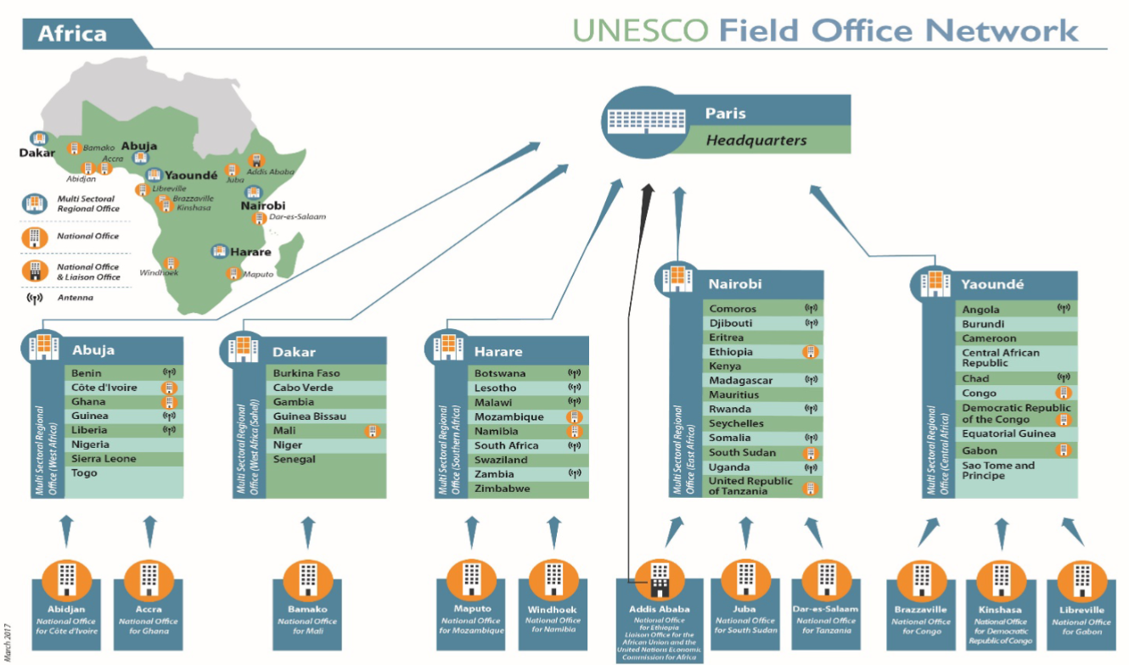

*Source: 201 EX/5.INF.2*

This is the only office in the current Field network that is National Office as well as Liaison Office, and located close to a Category 1 Institute. The latest proposal on the Field Network Reform proposes 2 options (8 regional and 42 country offices OR 18 regional and 32 country offices)

**Mission**

The UNESCO Addis Ababa Office comprises of the Liaison Office with African Union Commission (AUC) and the United Nations Economic Commission for Africa (UNECA) and the National Office for Ethiopia, under the Nairobi Multisectoral regional office, covering the East Africa region.[2]

**UNESCO Liaison Office to AUC and UNECA** has the function of:

* Institutional representation: promoting UNESCO’s mandate, programmes and activities
* Advocacy and outreach
* Information analysis and brokering: channeling and relaying information, including the Regional Coordination Mechanism (RCM) for Africa
* Building partnerships

**UNESCO National Office for Ethiopia** implements programmes and projects in all UNESCO fields of competence to foster a culture of peace and sustainable development in Ethiopia. Specifically the office:

* Enhances UNESCO’s support to national development priorities
* Develops and delivers UNESCO programmes in the country
* Engages in the mobilization of extra-budgetary resources at the national level
* Represents UNESCO and acts as a senior adviser to the Government of Ethiopia on matters pertaining to UNESCO’s mandate

**Context of the region**

The corruption perception indices (CPI) uses a scale of 0 (very corrupt) to 100 (very clean).

|  |  |  |  |  |
| --- | --- | --- | --- | --- |
| **Country** | **Population** | **CPI score** | **Rank /180** | **Comment** |
| Ethiopia | 120,5m[3] | 39 | 87 | CPI score is low but steadily increased since 2012. Score gained 1 point since 2020 |

*Source: <https://www.transparency.org/en/cpi/2021>*

|  |
| --- |
| UN AGENCIES |

UNESCO’s presence in Ethiopia represents the 1 percent in terms of UN international staff in Ethiopia as shown below.

**UN Staffing in Ethiopia:** 36 agencies; 1,496 international staff and 5,000 local staff; UNESCO ranks 20/36 based on total number of staff; UNESCO Staff (international + national) represents less than 0.8 percent of UN Total Staff (international + national) in Ethiopia.

*Source: UNDSS Staff List 30 September 2021*

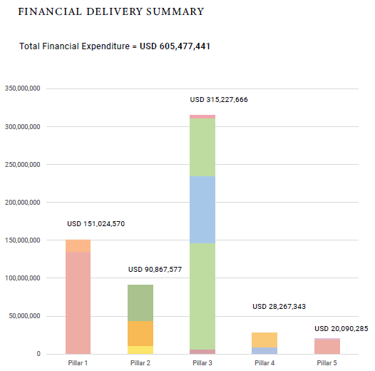

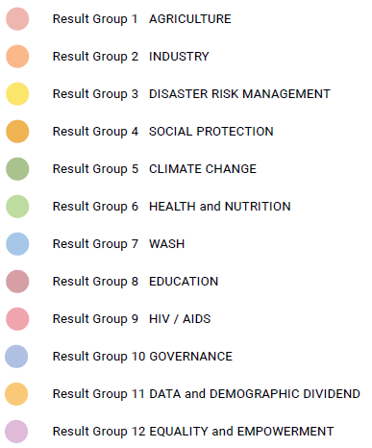

PILLAR # 1: Inclusive Growth and Structural Transformation

PILLAR # 2 : Resilience and Green Economy

PILLAR # 3: Investing in human capital and expanded access to quality, equitable basic social services

PILLAR # 4: Good governance, participation and capacity development

PILLAR # 5: Equality and empowerment

*Source: 2018 – 2020 Results Report for UNDAF 2016 – 2020*

As per 2016-2020 UNDAF, UNESCO mainly contributes to Pilar 3, and 1, 2, and 4.

For volume reference: UNESCO has a pledge of 6M USD in 2020-2025 UNSDCF for Ethiopia (Figure above shows that total financial expenditures of all UN agencies was 605M over 3 years 2018-2020)

|  |
| --- |
| OFFICE STRATEGY, STRUCTURE AND PORTFOLIO |

**UN and Office Strategy**

|  |  |  |  |  |
| --- | --- | --- | --- | --- |
| **Country** | **UNDP Human Development Index (HDI) 2020[4]** | **UNDAF or UNSDCF Period** | **UNDAF or UNDSCF priorities for the achievement of the SDGs**  *(source: ETHIOPIA - UNSDCF 2020-2025)* | **UCS Expected Results**  *(source: Draft UNESCO COUNTRY STRATEGY DOCUMENT ADDIS ABABA LIAISON OFFICE 2022-2025)* |
| **Ethiopia** | 0.485 (173rd position) – Low Human Development | 2020-2025 | * OUTCOME 1 - PEOPLE: All people in Ethiopia enjoy the rights and capabilities to realize their potential in equality and with dignity. * OUTCOME 2 – DEMOCRACY, PEACE and JUSTICE: All people in Ethiopia live in a cohesive, just, inclusive and democratic society. * OUTCOME 3 - PROSPERITY: All people in Ethiopia benefit from an inclusive, resilient and sustainable economy. * OUTCOME 4 – ENVIRONMENTAL PROTECTION AND CLIMATE CHANGE: All people in Ethiopia live in a society resilient to environmental risks and adapted to climate change. | **Education**: The national education strategy was developed under the Education Sector Development Plans (ESDP I - VI). Which are expected to be implemented in three macro-level development directions that include the Plan for Accelerated Development to End Poverty (PASDEP), the Growth and Transformation Plans (GTPs) and the incumbent Ten Years Development Plan (2021-2030). The ESDP aims to enhance the capacity of the education and training system to produce skilled human resources to meet the demands of the Lower- and Middle-Income Country (LMIC) national Vision by 2025. The action plans have also served as key management tools to adopt and nationally implement the MDGs, the SDGs and Agenda 2063, which focus on providing inclusive, equitable and quality education and training and promoting lifelong learning and development for all. UNESCO participated in the development and finalization of the sixth ESDP (ESDP VI), which Ethiopia has been implementing since 2020 as part of the national Ten Years Development Plan (2021-2030.) and in the development of the Education and Training Road Map. (FEEDS OUTCOME 3)  **Sciences, Technology and Innovation**: The Education and Training Road Map aspires to an education system emphasizing the knowledge and skills in sciences, engineering, art, mathematics (STEAM) and digital technologies. UNESCO had an opportunity to effectively collaborate with a strategic intervention in the curricula design, development, standard-setting and capacity building in collaboration with the Ministry of Science and Technology (MoST).  **Culture, Tourism and Heritag**e: Ethiopia has nine World Heritage Sites (WHSs) registered on the World Heritage List, eight of which are cultural while one is a natural site. However, civil conflicts, poor institutional (technical) capacity and a lack of political interest limit the UNESCO contribution in this area.  **Media, Journalism and Communications**: In 2021, the Media Proclamation No. 1238/2021 described in its preamble the right to freedom of expression and citizens’ freedom of the media which was guaranteed under the Constitution of the Federal Democratic Republic of Ethiopia, as well as in international human rights instruments which are binding on Ethiopia. UNESCO has provided capacity-building and technical support to enhance access to information and assess the media landscape through the UNESCO Media Development Indicators (MDI) framework and the community radio. (FEEDS OUTCOME 2)  **Liaison:** The liaison unit has been instrumental in advocating for UNESCO’s mandate and strategic intervention to support the implementation of the AU Agenda 2063 and the United Nations Agenda 2030. However, the liaison office had limited participation in funding and resource mobilization activities. In addition, except for activities such as supporting the preparation of ESDP VI in education, training and the culture sector, most of the strategic activities planned for 2019-2020 were not fully attained. |

**Office Scope**

The figure below shows the size of the office in terms of personnel and the volume of allocations in Regular Programme and Extrabudgetary funds in 2020-2021.

**Addis Ratio (a+b)_/ (c+d) = 1.98**

Personnel: 25 (14 FT, 4 PA, 7 SC) + 2 NRC + 1 Consultant + 1 volunteer

(a) Staff Costs (allocation 2020- 2021) :1.684 M USD

(b) Running and security costs (allocation 2020-2021): 530 K USD

(c) RP (ED, SC, CI, PAX activity budget allocations 2020-2021): 286 K USD

(d) Voluntary Contributions (expenditures in 2020-2021): 855 K USD

*Source : YFM1 ADI 2020-2021 and CJI3 expenditures in 2020-2021 of 570ETH1000, 570ETH1001, 549ETH4000 and relevant WBS of GLO and RAF projects*

**Donors’ landscape**

**Net official development assistance (ODA) per capita for Ethiopia = 38[5]**

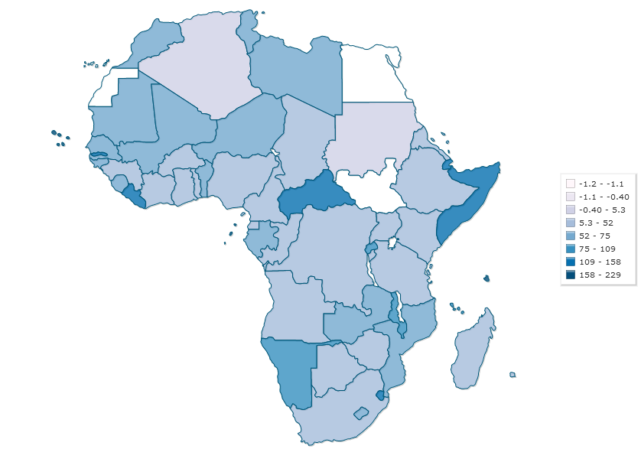

[*Source: Development Assistance Committee of the Organisation for Economic Co-operation and Development, Geographical Distribution of Financial Flows to Developing Countries, Development Co-operation Report, and International Development Statistics database*](https://www.indexmundi.com/facts/indicators/DT.ODA.ODAT.PC.ZS/map/africa)

**Resource Mobilization Strategy**

The Office developed a resource mobilization plan for 2020-2021 and identified the following niches *(source: UNESCO Addis Ababa Resource Mobilization and Partnership Building Strategy)*:

* Diversify the UNESCO Liaison Office and its partners resource base that is structured around common priorities reflected in relevant national and regional planning frameworks (including agenda 2063), highlighting opportunities for regional initiatives where possible
* Present options to broaden the scope and range of UN partnerships

The strategy note also identifies the following key challenges that continue to hamstring UN and joint efforts:

* Insufficient communication and coordination on partners’ work.
* Lack of robust data architecture to support efforts to strengthen coordination and information between partners.
* Lack of institutional processes to promote an inclusive approach to the identification development and implementing of joint initiatives.

The strategy identifies a three-step action plan that focuses on enhancing the existing inter and intra organizational learning architecture among public and private sectors across policy, practice and research spheres too identify and develop joint projects in support of common outcomes:

* Step One: Strengthen coordination structure with a clear focus on information management and partner ownership in the creation of national and regional initiatives
* Step Two: Develop a common analytical base and set of metrics to inform and gauge collective efforts (impact) towards common goals.
* Step Three: Develop and implement one to three joint initiatives together with public and private sector, civil society, academia partners that address one or more of UNESCO and its key regional and national partners in the areas of development, peace, and climate change.

UNESCO understands the aspirations and challenges faced its national and regional partners and is eager to partner to assist the country to overcome these challenges and help grasp the opportunities. The solution lies in leveraging UNESCO global expertise across four areas: (a) efficiency and effectives of its national and regional efforts; (b) strengthening private sector participation; (c) augmenting civil society and academia’s engagement; and (d) establishing new partnerships and sources of funding in support of the national and regional partners’ investments.

**Voluntary Contributions**

The Office managed three Voluntary Contribution projects directly in the last biennium which are financed by foundations (HP and Huawei) and EU.

|  |  |  |  |  |  |  |  |
| --- | --- | --- | --- | --- | --- | --- | --- |
| Budget code | Project title (full) | Donor | Sector | Valid from | Valid to | Allocation | CJI3 expenditures 2020-2021 |
| 570ETH1000 | **Enhancing Comprehensive Sexuality Educat** | David and Lucile Packard | **ED** | 08/31/2016 | 06/22/2021 | 766,848 | 86,478 |
| 570ETH1001 | **Enhancing Comprehensive Sexuality Educat** | PRIV. FUND. | **ED** | 12/16/2019 | 12/31/2022 | 400,000 | 141,506 |
| 549ETH4000 | **Promoting the Contribution of World Heri** | EUR.COM. | **CLT** | 01/12/2016 | 05/06/2022 | 442,958 | (7,826) |

The Office also implements activities with funds decentralized from HQ.

|  |  |  |  |  |
| --- | --- | --- | --- | --- |
| WBS | Project | Donor | Allocation | CJI3 expenditures  2020-2021 |
| 526RAF1003.2.1 | Better Education for Africa's Rise 2 (BEAR 2) | Rep. Korea | 245,102 | 133,343 |
| 526RAF1003.2.11.1 | Better Education for Africa's Rise 2 (BEAR 2) | Rep. Korea | 178,058 | 64,754 |
| 526RAF1003.3.1 | Better Education for Africa's Rise 2 (BEAR 2) | Rep. Korea | 405,831 | 384,705 |
| 570GLO1024.1.2 | Huawei - Technology-enabled Open Schools | Private Fund | 300,000 | 24,186 |
| 570GLO1024.2.2 | Huawei - Technology-enabled Open Schools | Private Fund | 45,000 | - |
| 570GLO1024.3.2 | Huawei - Technology-enabled Open Schools | Private Fund | 37,000 | - |
| 570GLO1024.4.2 | Huawei - Technology-enabled Open Schools | Private Fund | 23,000 | 3,401 |
| 201GLO1005.6 | Education in Emergency - Education Cannot Wait (ECW) Strengthening institutional Education information systems for data-driven EiE and resilience to crises | UNICEF | 657,426 | - |
| 257GLO1040.3.2 | UNAIDS UBRAF HIV prevention and comprehensive sexuality education (CSE) | UNAIDS | 71,697 | - |
| 257GLO1043.3.4 | UNAIDS UBRAF HIV prevention and comprehensive sexuality education (CSE) | UNAIDS | 27,757 | - |
| 257GLO1045.2.3 | UNAIDS UBRAF HIV prevention and comprehensive sexuality education (CSE) | UNAIDS | 37,383 | - |
| 547RAF1000.1.4 | O3 Our Rights, Our Lives, Our Future" programme | Ireland Government | 45,215 | 24,933 |
| 547RAF1000.2.4 | O3 Our Rights, Our Lives, Our Future" programme | Ireland Government | 55,052 | - |
| 547RAF1000.3.4 | O3 Our Rights, Our Lives, Our Future" programme | Ireland Government | 70,715 | - |
| 547RAF1000.4.4 | O3 Our Rights, Our Lives, Our Future" programme | Ireland Government | 42,500 | - |

**Evolution of the source of voluntary contributions projects for the Office**

Voluntary Contributions for the last 5 years are funded by Private foundations and EU.

*Source: based on YPS8 Total Allocation and start year on Vol cont. budget codes with Fund Center ADI*

*(Participation to GLO and RAF components is not reflected in the graph)*

**Regular Programme Budget**

The Regular Programme (RP) budget for 2022-2023 amounts to nearly US$3m, with a lower budget for programme activities than for Office’s running costs as shown in the table below.

|  |  |  |  |  |
| --- | --- | --- | --- | --- |
| **Budget / Biennium** | **2020-2021** | **%** | **2022-2023** | **%** |
| Office Running Costs | 530,324 | 22% | 473,426 | 16% |
| Programme Activities | 210,490 | 9% | 110,000 | 4% |
| Staff Costs | 1,683,690 | 69% | 2,358,429 | 80% |
| **Total** | **2,424,504** | **100%** | **2,941,855** | **100%** |

*Source: YFM1 2020-2021 and ADM/ASS monitoring Excel*

The 2022-2023 RP budget for programme activities is broken down by sector in the table below.

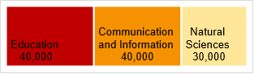

There is no direct RP for SHS and CLT. The programme sector assigns the RP to the regional Office in Nairobi, who would then assigned tasks and activities to different national offices under their scope.

**Leadership composition and organigram**

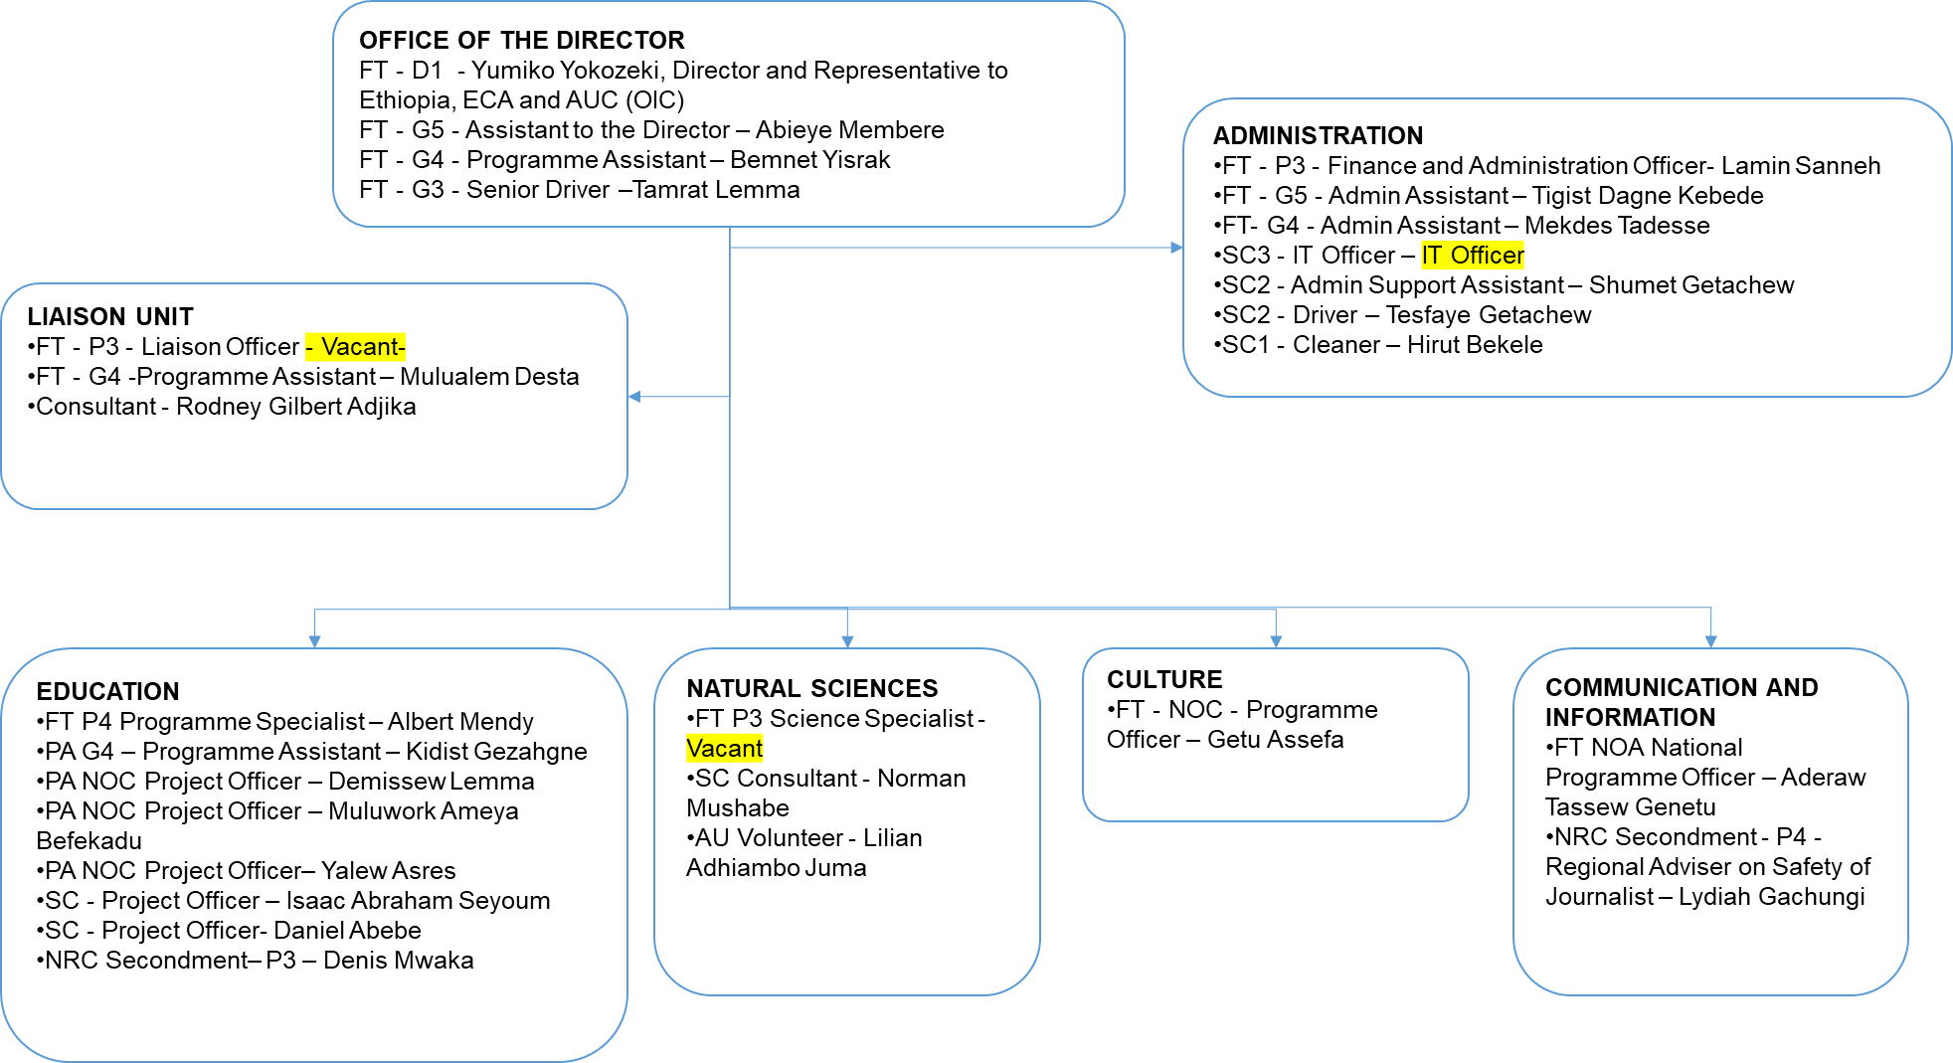

**Previous Heads of Office**

|  |
| --- |
| [Musa, Muhammed](http://www.unesco.org/ulis/cgi-bin/ulis.pl?database=&lin=1&futf8=1&ll=1&gp=0&pn=0&look=default&sc1=1&sc2=1&ref=http://www.unesco.org/ulis/cgi-bin/ulis.pl?mt=106%26req=2%26by=5%26sc1=1%26sc2=0%26look=azure_dg_note%26lin=1%26widen=1%26futf8=1%26pn=1%26text=Addis%2BAbaba%26text_p=inc%26noget=1%26submit=Ok&nl=1&req=2&text=Musa%2c%20Muhammed&text_p=phrase+like) (1993 - 1996) |
| Mamady Lamin Conde (1996 - 2003) |
| Awad El Hassan (2004 - 2007) |
| Nureldin Satti (2008 - 2009) |
| Luc Rukingama (August 2009 - December 2010) |
| Makarigakis Alexandros (OiC) (January 2011 - September 2011) |
| Firmin E. Matoko (October 2011 - December 2015) |
| Benno Boer (OiC) (April 2015 - June 2015) |
| Robertine Raonimahary (OiC) (July 2015 - August 2015) |
| Alaphia Wrigh (OiC)  (September 2015 - March 2017) |
| Yumiko Yokozeki (OiC) (April 2017 - June 2018) |
| Ana Elisa Santana Afonso (June 2018 - 28 Feb 2021) |
| Yumiko Yokozeki - OIC (1st March 2021 - ) |
| Rita will be appointed in July 2022 |

|  |
| --- |
| RISK MANAGEMENT |

**Risk Register**

The first RR of the office was finalized in February 2022.

The Office assesses that its internal controls area globally under control.

**Results of the 2020 Control Self-Assessment**

|  |  |  |
| --- | --- | --- |
| Functional Area | Self-Assessment (2020) | IOS Comments |
| Strategic framework, risk and control environment | Globally under control | No risk register |
| Programme Management | Needs improvement | 4 controls where objective partially met |
| Financial Control | Globally under control |  |
| Procurement and contracting | Globally under control |  |
| Human Resources Management | Globally under control |  |
| Travel Management | Globally under control | 2 controls where objective partially met |

*Source: CSA2020_Global ratings*

**Prior external assurance reports**

The 2010 IOS audit of UNESCO Addis Ababa National Office issued 13 recommendations covering the following challenges and opportunities:

* Give priority to resolving implementation delays for $4.1 million joint programme on Culture;
* Establish the Office Director’s expected results for the current biennium;
* Reinforce programme capacity by promptly recruiting for the Office’s vacant post in Communication & Information;
* Strengthen financial and administrative controls in several areas.

The 2007 IOS audit of UNESCO Addis Ababa Office identified weaknesses in internal control within the Office that need to be remedied and 56 recommendations were issued to help the Office to strengthen internal control.

|  |
| --- |
| CONTROL ACTIVITIES |

**Payment Process in SAP**

* Purchase orders: The creation of the purchase order in SAP lies on the dual validation from certifying officer and director. The dual control validation is embedded in the system for Purchase Orders payment through automated SOD for the creation of PO and MIRO (Good Receipt) transaction in SAP.

The key controls in this workflow are the following:

* + Segregation of duties between the PO creation and PO release
  + Verification of good receipts before doing the SES
  + Segregation of duties between MIRO and outgoing payment posting but SOD in the previous flow should be sufficient.
* Fund Reservation: The creation of fund reservation involves the administration unit only and should be used for exceptional circumstances, often for staff insurance, small purchases, etc.

The key control in this flow is the **independent verification** of the invoice posting through supporting documentation for justification between FB60 and F-53.

**Payments: WALKTHROUGH TO BE DONE**

**Bank Signatory:** No limit assigned for Bank signatories. Dual signatory is required for cheques and bank transfers. Since the last communication by Treasury on Cash Management (2019), the Office has largely moved to bank transfers. It is rare to pay in cash and cheques.

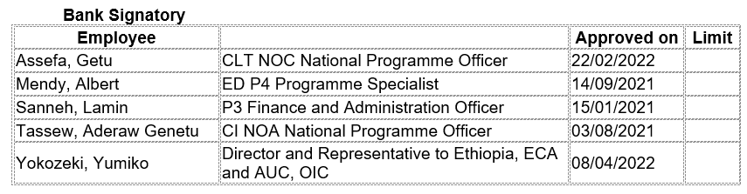

**Vendor management process**

* **SAP vendor creation**: **WALKTHROUGH TO BE DONE**
* **Local bank vendor creation**: **WALKTHROUGH TO BE DONE**

**Roles in Contract Management Tool / SAP (as currently released)**

The roles in DUO CMT are adequate with the staff’s posts and respect the segregation of duties.



*Source: CMT Role Tool*

**Key policies and documented procedures relevant to the audited area**

Most of the processes of the office are supposed to be carried out in line with the Admin Manual and the HR Manual.

**IT support and key systems:** The UNESCO ADDIS OFFICE network uses the patch panel of the UNECA network. The internet access of the office is via 50mbps connection subscribed from Ethio-telecom. There are five servers installed in a temporary server room.

|  |
| --- |
| DATA ANALYSIS |

The Office total expenditures between January 2020 to June 2022 totals US$4 million.

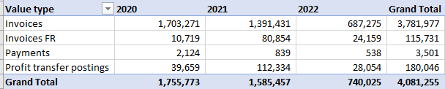

*Source: SAP FI Postings fund center ADI Jan 2020 – Jun 2022*

**Contracts Profile:** for the period January 2020 to Apr 2022, based on CMT

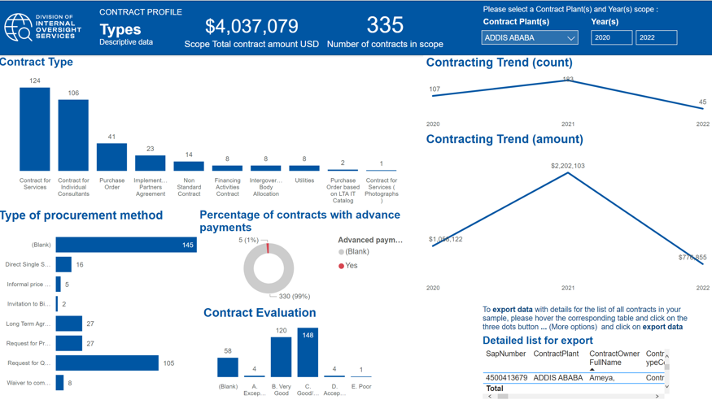

**Top vendors during period Jan 2020-Apr 2022 based on CMT**

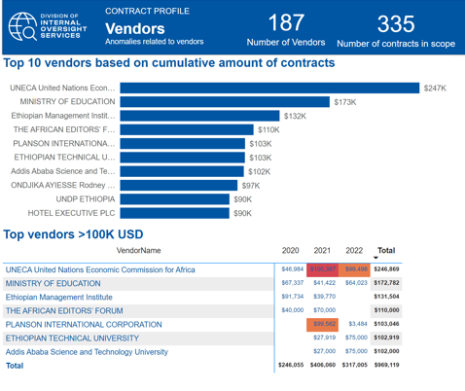

**Fund Reservations Profile**

Most of the Fund Reservations relate to the organization of meetings and conferences. In 2021 FRs were used to deal with the costs related to the evacuation of staff during the Tigray crisis.

| **FM GL Grouping** | **2020** | **2021** | **2022** | **Grand Total** |
| --- | --- | --- | --- | --- |
| Evacuation costs for staff |  | 150,338 | 7,440 | 157,778 |
| ATK Participants | 34,584 | 19,372 | 6,882 | 60,838 |
| DSA - Participants | 26,897 | 21,194 | 9,460 | 57,551 |
| Contributions to UN joint activities |  | 50,000 |  | 50,000 |
| Contract for Services |  | 48,760 |  | 48,760 |
| Telephone | 2,125 | 8,984 | 8,458 | 19,566 |
| Residential security measures in the field |  | 17,500 | 500 | 18,000 |
| Staff removal |  | 8,000 | 8,000 | 16,000 |
| Vehicles maintenance & repairs | 4,901 | 4,000 | 5,803 | 14,704 |
| Consultants to Secretariat & Memb States (remunera |  | 13,000 |  | 13,000 |
| Other communication expenses | 3,493 | 646 | 4,680 | 8,820 |
| Receptions costs | 8,346 |  |  | 8,346 |
| Other insurance premiums | 1,433 | 1,300 | 916 | 3,649 |
| Communication equipmt purch (incl audio video equi |  | 1,306 | 390 | 1,696 |
| Vehicles purchases | 1,089 |  |  | 1,089 |
| Training Workshop & Seminars |  | 999 |  | 999 |
| Other charges and commissions | 945 |  |  | 945 |
| Consultants - insurance | 378 | 309 | 137 | 824 |
| Office supplies purchases | 539 | 105 |  | 645 |
| Other supplies purchases | 400 |  | 104 | 504 |
| Staff members mission costs - Other travel costs |  | 198 | 120 | 318 |
| Freight - insurance |  | 300 |  | 300 |
| Pouches | 283 |  |  | 283 |
| Computer licences costs |  | 141 | 137 | 279 |
| Gas & oil | 170 |  |  | 170 |
| Carbon tax on other travellers |  | 100 |  | 100 |
| ATK individuals and others |  | 66 |  | 66 |
| Printing invitations, professional visiting cards |  | 55 |  | 55 |
| Staff members mission costs - Air tickets |  | 8 |  | 8 |
|  | **85,583** | **346,681** | **53,029** | **485,292** |

*Source : SAP FIPostings 2020-2022 as of June 2022*

**Travel Data:** Travel dropped in the last years due to Covid and little resources

*Source: Travel Claims Tool*

| **FM Traveller Name** | **Traveler Grade** | **Destination Country** | **Total** |
| --- | --- | --- | --- |
| **Mama Plea** | **P-3** | Cameroon | 13 |
|  |  | Chad | 2 |
|  |  | Côte d'Ivoire | 1 |
|  |  | Ethiopia | 6 |
|  |  | France | 2 |
|  |  | Gabon | 2 |
|  |  | Kenya | 2 |
|  |  | Mali | 1 |
|  |  | Senegal | 1 |
|  |  | Togo | 1 |
|  |  | Zimbabwe | 1 |
| **Mama Plea Total** |  |  | **32** |
| **Tesfaye Getachew Ayele** | **SC2** | Ethiopia | 30 |
| **Tesfaye Getachew Ayele Total** |  |  | **30** |
| **Demissew Lemma** | **NO-C** | Ethiopia | 25 |
|  |  | Kenya | 1 |
|  |  | United States | 1 |
| **Demissew Lemma Total** |  |  | **27** |
|  |  |  |  |
| **Albert Mendy** | **P-4** | Cameroon | 10 |
|  |  | Chad | 4 |
|  |  | Ethiopia | 4 |
|  |  | France | 2 |
|  |  | Gabon | 2 |
|  |  | Guinea-Bissau | 2 |
|  |  | Kenya | 1 |
|  |  | Tanzania Un Rep | 1 |
|  |  | Zimbabwe | 1 |
| **Albert Mendy Total** |  |  | **27** |
|  |  |  |  |
| **Getu Assefa** | **NO-C** | Côte d'Ivoire | 1 |
|  |  | Egypt | 1 |
|  |  | Ethiopia | 16 |
|  |  | France | 1 |
|  |  | Kenya | 4 |
|  |  | South Africa | 1 |
|  |  | Thailand | 1 |
| **Getu Assefa Total** |  |  | **25** |
| **Shumet Getachew** | **SC2** | Ethiopia | 24 |
| **Shumet Getachew Total** |  |  | **24** |
| **Muluwork Befekadu Ameya** | **NO-C** | Ethiopia | 16 |
|  |  | Ghana | 1 |
|  |  | South Africa | 3 |
|  |  | Tanzania Un Rep | 1 |
| **Muluwork Befekadu Ameya Total** |  |  | **21** |
| **Aderaw Genetu Tassew** | **NO-A** | Cameroon | 2 |
|  |  | Ethiopia | 11 |
|  |  | Ghana | 1 |
|  |  | Jordan | 1 |
|  |  | Kenya | 3 |
|  |  | Lebanon | 1 |
|  |  | Uganda | 1 |
| **Aderaw Genetu Tassew Total** |  |  | **20** |
|  |  |  |  |
| **Ana Elisa Santana Afonso** | **D-1** | Algeria | 1 |
|  |  | Angola | 2 |
|  |  | Congo | 1 |
|  |  | Ethiopia | 10 |
|  |  | France | 2 |
|  |  | Gabon | 1 |
|  |  | Germany | 1 |
|  |  | Japan | 1 |
|  |  | Kenya | 1 |
| **Ana Elisa Santana Afonso Total** |  |  | **20** |
| **Samuel Asnake** | **NO-C** | Egypt | 1 |
|  |  | Ethiopia | 9 |
|  |  | France | 1 |
|  |  | Senegal | 1 |
|  |  | South Africa | 2 |
| **Samuel Asnake Total** |  |  | **14** |
| **Kidist Gezahgne** | **G-4** | Ethiopia | 12 |
| **Kidist Gezahgne Total** |  |  | **12** |
| **Tamrat Lemma** | **G-3** | Ethiopia | 10 |
| **Tamrat Lemma Total** |  |  | **10** |
|  |  |  |  |
| **Kassahun Abate** | **SC4** | Angola | 1 |
|  |  | Ethiopia | 8 |
| **Kassahun Abate Total** |  |  | **9** |
| **Bemnet KEBEDE YISRAK** | **G-4** | Ethiopia | 7 |
| **Bemnet KEBEDE YISRAK Total** |  |  | **7** |
|  |  |  |  |
| **Lamin Sanneh** | **(blank)** | Ethiopia | 2 |
|  |  | France | 2 |
|  |  | Gambia | 2 |
| **Lamin Sanneh Total** |  |  | **6** |
| **Leah Merid Alemu** | **G-4** | Ethiopia | 5 |
| **Leah Merid Alemu Total** |  |  | **5** |
| **André Touré** | **P-3** | Kenya | 1 |
|  |  | Senegal | 2 |
| **André Touré Total** |  |  | **3** |
| **Mulualem Desta** | **G-4** | Ethiopia | 3 |
| **Mulualem Desta Total** |  |  | **3** |
| **Moges Negede Belete** | **SC3** | Ethiopia | 1 |
|  |  | France | 1 |
| **Moges Negede Belete Total** |  |  | **2** |
| **Tigist Dagne Kebede** | **(blank)** | Ethiopia | 2 |
| **Tigist Dagne Kebede Total** |  |  | **2** |
| **Gelila Tesfaye Gebru** | **NO-B** | Kenya | 1 |
|  |  | Namibia | 1 |
| **Gelila Tesfaye Gebru Total** |  |  | **2** |
| **Isaac Abraham Seyoum** | **SC5** | Ethiopia | 2 |
| **Isaac Abraham Seyoum Total** |  |  | **2** |
| **Mekdes Tadesse** | **(blank)** | Ethiopia | 1 |
| **Membere Abiey** | **G-5** | Ethiopia | 1 |
| **Yalew Asres** | **NO-C** | Ethiopia | 1 |
| **Daniel Mekete** | **SC5** | Ethiopia | 1 |
| **Hirut Bekele** | **SC1** | Ethiopia | 1 |
| **Grand Total** |  |  | **308** |

**Unliquidated Obligations as of June 2022** *Source: BFM Dashboard* **(OK)**

**Travel**

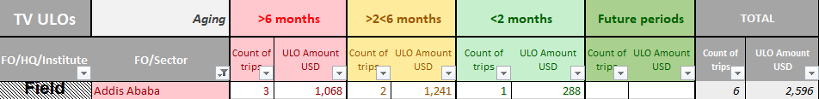

**Purchase Orders**



**Fund Reservations**



**Good Receipt Not Invoiced**

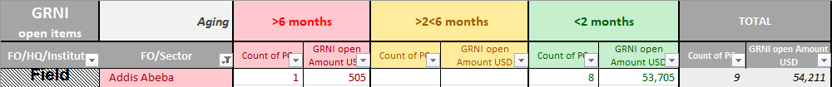

|  |
| --- |
| INFORMATION AND COMMUNICATION |

**Internal reports used and systems for data extraction**

* The Office uses the corporate tools iRIS

**External reports and target audience, including any feedback from the audience**

* The Office shared examples of communication materials to advocate the liaison role.

**Social media reports for any positive or negative press about the programme/projects:**

The office maintains a website in English with links to UNESCO news as well as publications relevant to the country.

UNESCO Addis Ababa website : <https://en.unesco.org/fieldoffice/addisababa>

UNESCO social media platforms : Facebook (<https://www.facebook.com/unescoofficeaddis>) and twitter (<https://twitter.com/unesco_addis0>

|  |
| --- |
| PARTNERSHIPS |

**UNESCO Chairs**

* There are two UNESCO Chairs in Ethiopia as shown in the table below.

|  |  |  |  |
| --- | --- | --- | --- |
| **Chair Title** | **Fields/Disciplines** | **UNESCO Section** | **Year Establish.** |
| **UNESCO Chair in Education for Human Rights and Democracy** | **Human Rights and Democracy.** | **SHS/INC** | 1994 |
| **UNESCO Chair on Water Resources Planning and Environmental Engineering** | **Water resources planning and environmental engineering** | **SC/HYD** | 2016 |

**UNESCO Category 2 centers**

* There is one Cat 2 center in Ethiopia approved in 38 C5 but agreement still not signed?

|  |  |  |  |  |  |  |
| --- | --- | --- | --- | --- | --- | --- |
| **Serial** | **Sector** | **IOS Number** | **Country** | **City** | **Name of Centre** | **Approval GC** |
| 69 | SC | SC20 - IHP | Ethiopia | Addis Ababa | African Regional Centre for Ecohydrology | 38C |

**UNESCO Liaison Office with African Union Commission (AUC)**

**UNESCO Liaison Office with United Nations Economic Commission for Africa (UNECA)**

|  |
| --- |
| PRELIMINARY FINDINGS |

**UCSP 2022-2025 :** Funding and resource mobilization efforts at the level of Addis Ababa UNESCO LO have significantly declined over the last decade. Above all the LO seems to have lacked strong leadership and clear strategic direction on its own overarching objectives, goals, core values and expected results, which has created difficulty to measure success and demonstrate performances.

Except for activities such as supporting the preparation of ESDP VI in education and training, and PPE in the culture sector, hardly any of the strategic activities planned in the 2019-2020 CSP of the UNESCO Addis Ababa LO were fully attained. Accordingly, most of the activities intended to be implemented were on-going and /or unfinished while activities such as support to mainstreaming peace education and resilience, gender in higher education, and development of science and technology policy didn’t entirely start by the time these data were collected[6]. COVID-19 along with the armed ethnic internal conflicts in various regions and the civil war in the northern part of Ethiopia had significant adverse pressures on implementing the plan[7]. Other organizational factors such as financial constraints and unavailability of relevant professional staff and specialists in the Office for some sectors are also being critical obstacles. And the sum of these precarious factors is likely to degrade UNESCO LO’s leveraging power and comparative advantage on high level policy and strategy issues in its priority sectors and fields of competence[8]

**Relevant minutes of the meetings**

| **Name** | **Sector** | **Preliminary findings - Addis** |
| --- | --- | --- |
| Magdalena Landry | PAX | Turnover of Directors, OIC in place for more than a year, Liaison unit vacant post in Addis.  Dual reporting role to PAX and Nairobi office.  The current version of the Host Country Agreement is probably non-compliant. For example, the country is not providing the expected premises or buildings. It is not the best time to review this agreement, and it is not a priority.  The political situation poses security threats, the pandemic slowed down office activities in 2020, and the transitional period in the field office leadership delayed the decision-making process of strategic nature |
| Bowe, Malebogo | PAX/AFR/ASP  Previous Liaison Officer, now in HQ | Turnover of Directors impaired collaboration with AU.  Importance of connecting with groups through the Regional Collaboration Mechanism (RCM), later called Regional Collaboration Platform (RCP).  Examples of frictions in double reporting: Nairobi for the National Office and PAX for the liaison Office |
| Mekdes Edjigayehu-Grandclaude | ADM/ADS | The role of the Liaison and National office needs to be clarified. For example, there was a mission from UNESCO to the African Union without the knowledge of the Addis Office or the Institute.  Clarification needed about their resource mobilization role.  Impact of the introduction of new salary structure for SC by UNDP foreseen for 2023.  Security risk of having an IT person on SC contract.  Need for the prompt and regular replacement of staff to avoid capacity gaps |
| Yumiko Yokozeki, Lamine Sanneh | DIR/IICBA, AO/Addis | Need more effort in Resource Mobilization, Office implements what is received. Needs to diversify.  Trying to get an M&E consultant /post to support Addis and ICBA, but lack of resources.  Unclear modalities and impacts of UN reform (mission in May ACABQ).  Challenge for the new Liaison officer to come is to ensure the mission: Information analysis and brokering channeling and relaying information, including the Regional Coordination Mechanism (RCM) for Africa and Building partnerships.  HQ often bypass the Liaison role to AU and this creates a burden as Addis has then to fix situations.  It is challenging to keep up with AU (delays, follow-up, restructuring).  Need more formal, regular coordination mechanism with liaison office + MSROs would improve.  Lack of capacity at the level of the national Office to support the Liaison Office (except CI for the moment). |
| Gachungi, Lydia ; Tassew Aderaw Genetu; | Adviser on Freedom of Expression and the Safety of Journalists,  NATIONAL PROFESSIONAL CI OFFICER | Confusion Liaison is continental and not regional ex : CI has regional Advisers in MSRO Dakar, Nairobi, Harare.  Absence of Cost recovery when CI support the Government.  Opportunities for resource mobilization - drafted. |
| Norman Mushabe | Nat. Sciences Consultant | No Prog specialist since Mama Plea left (1 year) HQ do not decentralize funds Nat SC Consultant participate to meetings, provides support to the liaison office but cannot engage much further with stakeholders |
| Lemma, Demissew ; Ameya, Muluwork Befekadu; Asres, Yalew | Addis ED Project Officers | Concerns on knowledge management: due to turnover in PS, DIR, and assistant, and remote work of the P4 PS, there is a risk of loss of institutional memory. This was shared with DIR and HRM but no action taken.  The liaison office needs more resource to function properly. Due to the lack of resource, National Officers often have to add AU work on top of their normal National duties.  Depending on the Director, the AU continental priorities become the priority to the disadvantage of national priorities. Note that AU priorities not always are aligned with Ethiopia priorities, AU always has to be aligned with CESA.  Very confusing especially for new ppl. Need orientation what is priority |
| Getu Assefa, and 2 assistants | Addis CLT Project Officer | Liaison Office with a National Office is a very good strategical idea. But with scarce resources in CLT (one NOC working on all conventions with one assistant to support logistics), the capacity is limited. In addition, working with AU is demanding strict follow-up and shifts priorities. Lack of support from HQ for instance from BSP when mobilizing resources, more challenging than supportive. Need refreshing training. Know resource mobilization guide but need more guidance especially for budget in proposals. |
| Ondjika, Gilbert Rodney ; Mulualem | Liaison unit Consultant and Assistant | Lack of HR capacity, within the Liaison unit currently only consultant + one G in Addis, and within the National office programmes (ED PS is working remotely, no SC PS only consultant, no SHS PS, only one CLT NOC. Only CI has currently sufficient liaison capacity thanks to NRC Lydia. Lack of resource, no RP, PAX just funds the consultant contract.  Liaison Office collaboration is very effective only with 3 MSRO (Nairobi, Dakar and Yaoundé), interaction on ED matters with Abuja. Zero interaction with MSRO in Harare.  Very limited contacts with ECA. |

|  |
| --- |
| AUDIT RATIONALE, SCOPE AND OBJECTIVE |

**Audit rationale**

The Office was last audited by IOS in 2010. The Category 1 Institute IICBA was in the 2022 Audit plan. The DIR of ICBA has been OIC of Addis Office for more than a year, and The AO of Addis is also supporting ICBA.

**Audit objective**

The objective of the audit is to provide assurance on the effectiveness of internal controls, governance, and risk management processes of the Addis Ababa Liaison Office to the African Union and the United Nations Economic Commission for Africa. Furthermore, the audit will review the efficiency, effectiveness, and economy of the Office’s operations (including programme management, financial controls, procurement, travel, human resources management, security, IT, and general administration).

**Audit scope and period**

The audit will cover the Programme activities from 1 January 2020 to 30 April 2022, the audit team may also review other periods if necessary. The audit is planned as a full scope exercise. The audit will cover the following areas:

* Overall governance of the Office (including objective setting, planning, and risk management)
* Programme
* Financial control
* Contracting and procurement
* Travel
* Human resources
* General administration

**Audit methodology**

The audit will be performed in accordance with the *International Standards for the Professional Practice of Internal Auditing* and IOS audit manual.

The audit will assess the functioning of internal controls within the defined scope in order to identify major risks to the achievement of the San Jose objectives. Action plans will be agreed to strengthen risk management and controls, and to improve operations where warranted.

The audit will be based on interviews, data analysis and documentation review. The audit team will select the sampling techniques such as judgmental, or statistical to ensure the sampling approach remains relevant to the test objectives.

**Key milestones**

IOS will conduct the audit of the Office per these timelines:

| **Milestone** | **Planned date** |
| --- | --- |
| Notification letter | 04 May 2022 |
| End of planning | 01 June 2022 |
| End of fieldwork | 21 June 2022 |
| Draft report | 11 July 2022 |
| Final report | 31 July 2022 |

**Audit resources**

The budgeted days for this assignment are 80 days as follows:

|  |  |  |  |  |  |
| --- | --- | --- | --- | --- | --- |
| **Activity/ Persons-days** | **Planning** | **Fieldwork** | **Draft report** | **Finalization** | **Total** |
| Head of Audit (Soriano) | 1 | 0 | 1 | 1 | 3 |
| Principal Auditor (Purkait) | 4 | 10 | 2 | 1 | 17 |
| Auditor (Moutard) | 8 | 30 | 10 | 2 | 50 |
| Consultant Auditor (Teodoro) | 5 | 5 |  | 0 | 10 |
| Total | 18 | 45 | 13 | 4 | 80 |

|  |
| --- |
| Annex 1 – Risk Matrix and Work Programme |

|  |  |  |  |  |  |
| --- | --- | --- | --- | --- | --- |
| **Objective Title** | **Risk Description** | **Control Description** | **Keep ?** | **Concerns or good practices identified** | **Audit Tests** |
| GOV_O01_To carry out UNESCO's mandate effectively and efficiently in the field | Unclear objectives may result incoherent activities that not aligned with UNESCO's mandate, national priorities or the UN framework | The office maintains an up-to-date UNESCO Country Strategy developed in consultation with government stakeholders in line with UNESCO's and national priorities and Sustainable Development Goals (SDG) | **IRA** | UCS have been provided for the five countries. They are general and repetitive for some sectors.  **Through interviews, determine how these UCS were developed.** | Verify that:  1. the UCS is up-to date and UNESCO objectives are valid and in line with the C/5 and national priorities 2. government stakeholers, national commissions along with the UN System (UNSDCF Framework) have been consulted in setting priorities 3. if there are major divergences in priorities (based on stakholders interviews).    Through interviews with the PS, determine how the UCS was developed and their views on the regional needs. |
| GOV_O03_To manage risks to the office’s objectives | Failure to identify and mitigate risks to an acceptable level may lead to failure to achieve Office objectives | Risk assessment process resulting in a risk register and the principal risks have been reduced to an acceptable level | **IRA** | The Risk Register was last updated in 2018. | Verifiy that:  1. a risk register has been prepared, is complete and updated regularly 2. if fraud risks been considered and if a Fraud and Corruption Risk, that the Office has prepared an action plan and is actively monitoring it with clear accountabilities for each action.  No test deemed necessary – potential finding. |
| HR_O02_To staff the Office adequately to meet plans and expectations of the Member State and other | Office capacity may be inadequate resulting in poor programme delivery. | 1. The section for Administration Support (ADM/ADS) maintains the Administration unit structure based on the Office's role and portfolio.  2. Programme sectors dedicate posts based on the needs of the Office.  NB: A field reform has been ongoing to optimize human resources | **IRA** | The Office is well staffed with 12 international staff (HoO, 7 PS, 1 Res Mob officer, AO, 4 GS, etc) One G-5 post is vacant which ADM/ADS has not filled given the low level of EXB funds. | Review Workforce planning: 1. Verify that staffing needs have been assessed by the FO, together with ADG of the Sectors, BFM & PAX and that a recruitment plan for all professional posts, NPOs and GS Staff has been prepared for the biennium.  2. Calculate and analyze staffing ratios and compare them with other offices (programme portfolio vs number of programme staff in unit, number of admin staff vs total staff number, cost of admin staff vs total costs of personnel in office).  (//whether the office has enough staff to carry out its mandate and to what extent it depends on temporary staff vs. fixed term). |
| GOV_O01_To carry out UNESCO's mandate effectively and efficiently in the field | Insufficient donor funding may result in ineffectiveness and jeopardize the Office's sustainability | • The Office maintains and regularly updates a Resource Mobilization plan aligned with the UCS and the C/5 • BSP deployed regional experts in Resource Mobilization to Dakar, Bangkok, Jakarta and Nariobi, San Jose and Beijing. • BSP's 2021 guidance note to field offices to develop a resource mobilization plan | **Added** | The Office developed a RM plan for 18-19 and 20-21 and recruited a RM officer.  The region does not attract large projects. PAX counts on the new HoO to mobilize funds through his network for Education in Sustainable Development. | Verify if the Office established an adequate Resource Mobilization (RM) Plan.  + **Review the RMO Job description and performance assessment** |
| GOV_O01_To carry out UNESCO's mandate effectively and efficiently in the field | Failure to leverage the UN network may decrease operational efficiency and diminishes visibility | Alignment with the UN Framework and participation in UNCT meetings | **Added** | Most UN agencies are located in Panama not Cost Rica.  The government is keen on keeping the Office. | 1. Interview the Resident Coordinator and use the interview guide to:  - determine whether UNESCO's activities are consistent with national priorities and needs - UNESCO contributes to the UN Framework and works well with other agencies   2. Verify that the Office is represented at all UN Country Team meetings. |
| GOV_O01_To carry out UNESCO's mandate effectively and efficiently in the field | Outdated HCA may undermine the Office’s legitimacy, privileges, capacity to deliver and accountability exposing it to legal and financial risks | PAX has reviewed in 2016 HCAs to identify missing or outdated HCAs for renegotiation.   In 2022, PAX will renew the review of HCA to identify opportunities and challenges. | **ADDED** | The government pays for the premises but rental costs remain high to the Office. The Office paid ILEJI SA then Condomiunm Vertical and then Centro de Negocios El Cedral CNEC between 2018 and 2022. | Through an Interview of PAX and Head of Office, determine whether the HCA is up-to-date including the geographical scope, premises and VAT exemption. |
| GOV_O02_To leverage effectively UNESCO’s network | Lack of engagement with partners can result in missed opportunities | Clear roles and responsibilities, lines of communication, regular interactions and involvement at programme/project levels where relevant. | **ADDED** | The UCS for the 5 countries mention the different partnerships with UNESCO Chairs (one in Costa Rica and one in Nicaragua). | Determine if there are focal points appointed to engage with the various partners identified in the field. |
| GOV_O07_To raise the visibility of UNESCO as an effective partner in its area of competence | "Misuse" of UNESCO’s logo may lead to reputational damages | Monitoring of UNESCO logo usage through regular programmatic engagement | **ADDED** | There are a five UNESCO Chairs in Costa Rica and Nicaragua in ED, SC and SHS areas. | Verify if the Office engages actively with the UNESCO Category 2 Institutes and Chairs in the region. |
| GOV_O08_To produce publications efficiently according to UNESCO’s publication guidelines | Lack of quality control over publications expose UNESCO to reputational risks | Annual publication plan and publications produced. | **NOT ADDED** | The Office has not produced any recent publications. | 1. Verify that the office prepares an annual publication plan which is submitted to DPI. 2. Assess that the publication planning addresses (i) objectives, (ii) relevance, (iii) target audiences, (iv) linguistic diversity, (v) timeline, (vi) cost efficiency, (vii) distribution plan and strategies and impact measurement and (viii) qualitative and quantitative indicators to measure the distribution and impact of a publication. 3. Review a sample of publications produced by the Field Office. |
| PROJ_ O01_To implement activities/ projects in accordance with the project plan | Delays in Project implementation will negatively impact our relationship with donors and UNESCO's reputation | Projects documents have all mandatory information for better planning and execution | **KEEP FOR ALL** | The Office has very few low-amount projects which are nearing completion. | Select a judgemental sample of RP activities and Projects. Review the project documents and verify that: **Planning** 1. the project document is complete and includes (i) relevance, (ii) focus, (iii) a clear logical framework with realistic performance indicators at the output level, (iv) risk analysis; (v) budget by activity, (vi) timeline, (vii) monitoring and evaluation framework; (viii) sustainability; 2. the project risk analysis is done correctly and identify all high risks and mitigating measures; 3. the budget allocates adequate staff time for cost recovery (HoO and Programme Specialist); 3. the monitoring mechanisms are adequate to track progress and mitigate risks identified, and if applicable the project steering committee is established; 4. if applicable the project has been screened by the High Risk Project Committee prior to agreement signature.  **Monitoring and Evaluation**  5. activities are on schedule and if not, delays have been communicated with the donor 6. a monitoring and evaluation framework is in place and updated on a regular basis to track progress by outputs, activities and expenditures;  7. a mid-term and final evaluations have been conducted as required; 8. any lessons learnt has been documented and shared (via SISTER or other means)  **Reporting** 9. financial and narrative reports are submitted in line with donor requirements 10. the donor is satisfied with the communication surrounding the project (interview of the donor)  11. implementation progress is recorded in SISTER  12. Reports on gender markers are correctly done when applicable (in SISTER) |
| PROJ_ O02_To embed Global priority Gender in projects | PM_Gender markers are not embedded in operations and programmes preventing implementation of the Gender Equality Action Plan 2014-2021 | Programmes/projects focus on the global priority Gender Equality  The Office has assigned a staff the Gender Focal Point role | **ADDED** | The gender markers are correctly recorded for the four UN projects under the Office’s fund centre. | For a selected sample, verify that:  1. the project contain clear assumptions, baselines and RBM linkages to implement and monitor progress on Gender Priority 2. gender markers have been correctly assigned and corresponding reporting indicates the effort required, results achieved and captures monitoring information  Through interviews, verify if:  1. a staff has been assigned the role of Gender Focal Points 2. trained on Gender Equality training and  3. is being consulted for workplace issues or developing project proposals/designing and reviewing the office workplans |
| PROC_O01_To contract the most appropriate service, technical expertise | Poor planning leads to sub-optimal procurement outcomes.   R1. Contract price may be too high resulting in financial losss   R2. Goods and services may not be verified and inspected resulting in financial loss  R3. Performance assessment is not objective resulting in resorting to poor-performing vendors | • Certification and Approval in system to ensure compliance with AM: - Clear TOR including SMART deliverables - Competitive selection, comparison for commitment above certain amounts - Verification and inspection of deliverables for contracts and M&E for IPAs (SES) - Contracts Committee compliance review for commitments above $150 000  • Segregation of duties: Requestion, Certifying and Approving Officer | **KEEP FOR ALL** | A judgemental sample of contract has been drawn based on the top vendors and ULOs. This sample can be extended based on the vendor account test results. | **Contracting and Procurement** For sample of purchase orders created in SAP, verify that:  1. the purpose of procurements is justified and relevant to the project’s/activity’s objectives and foreseen in the project documents if VC funds are used  2. the terms of reference (or product specifications) are well defined, framed before initiating procurement action, clear and complete to allow for price comparison. (NB: Requirements must be stated clearly, concisely and logically in functional and performance terms, unless specific technical requirements are needed. Equal opportunity must be provided for all potential suppliers to offer goods and the usage of a brand name shall be avoided. *Sustainable procurement criteria should be considered to the extent possible)*   3. the contract is awarded in a competitive manner and if evidence of review that the cost is reasonable is documented (through waivers, IPA, LTA, etc);  4. the contract is managed correctly, i.e. a) SES are done after receipt and inspection/verification of the deliverables (PAs, narrative reports are submitted on a regular basis,  5. performance assessment is done in an objective manner. |
| FIN_O01_The office effectively manages the budget and monitors its financial performance | Inadequate budget management practices lead to poor budget implementation, budget cross-charging and ULOs | • The Certifying Officer is responsible for verifying that the correct budget code is used when certifying a payment.   • The budget holder can verify payments from a budget code | **KEEP FOR ALL** | Few ULOs for FR and many for the Pos. | **Budget Management** 1. Perform a walkthrough with the AO unit to identify the Office's controls that ensure payment is charged to the right budget codes including those of decentralized funds including GLO, RAS, RAF, etc .   2. Select a judgmental sample of transactions to verify that: they are charged to the correct budget code.    3. Determine how the Office monitors budgets (e.g. budget implementation rates, obligations, advance payments etc.) and obtain supporting documentation for review to assess the control, its regularity and involvement of Head of Office and senior staff.  3. Analyze the budget implementation rates and the level of unliquidated obligations for the different Units and activities of the Office (including for the Office Running Costs).   4. Review the actions taken by the office to address exceptions. |
| FIN_O01_To manage the budget and monitors its financial performance | Lack of monitoring exposes the Organization to funds misappropriation, unfunded liabilities, compromised financial reporting and financial loss | • The Certifying Officer is responsible for verifying that the correct budget code is used when certifying a payment.   • The budget holder can verify payments from a budget code | **KEEP FOR ALL** | A walkthrough performed on March 10th to identify roles and responsibilities of the staff in the Administrative unit (Dilcia Alvarez and Tammy Sanchez) indicates that the AO is performing all the payment transactions (FB60 and F-53) as well as the bank reconciliation and therefore segregation of duties is not respected in the payment process. | **Controls over payments** 1. Confirm independently with the local bank(s) that all open and recently closed Office bank accounts were opened by the CFO or Treasurer and the Office does not hold any other bank accounts.   2. If the Office still uses bank transfer letters, establish the workflow to determine whether proper segregation of duties is in place and test a sample of payments. If the Office uses the online bank platform, perform a walkthrough of the payment process on the bank website to determine whether proper controls are in place (dual validation over payments) and obtain the list of all the vendors created online during the walkthrough to avoid any file alteration.   3. Verify that the Head of Office when appointed signed and returned acknowledgement of financial management and control (delegation of authority) to the CFO.   4. Perform a walkthrough of payment process in SAP and verify that segregation of duties is respected between the posting of invoices (FB60), clearing of payment (F-53) and performance of the bank reconciliation.    5. Perform a walkthrough of the bank vendor creation process and verify that vendors are first created in MOUV first and that bank account details match those in the internet banking tool. In the absence of a banking tool, select a sample of payments and verify that bank account details in bank transfer letters match those in SAP and are supported by official bank documents that prove vendor name match the bank account information.   6. Select a judgemental sample of payments to assess the effectiveness of the above controls and verify that the payment is (i) valid, (ii) authorized and (iii) supported. |
| FIN_O01_To manage the budget and monitors its financial performance | Lack of monitoring exposes the Organization to funds misappropriation, unfunded liabilities, compromised financial reporting and financial loss | Field Offices record of petty cash transactions in SAP and perform regular reconciliations | **KEEP FOR ALL** | NB The Office uses cheques only to cash them for the petty cash and uses cash for the OIC's DSAs. | **Petty Cash** Perform a surprise count of the petty cash kept in the Office and verify that: cash is kept in a locked and cash transactions are recorded in the SAP petty cash account supporting documentation is maintained for cash receipt and disbursement segregation of duties is established for the cash management |
| HR_O01_To define clear expected results and objectives for HoO | Performance objectives of HoO and all staff not established so HoO and staff are not assessed against deliverables | HoO and all staff are subject to biennial performance review (Nidza Monthy maintains data) | **KEEP FOR ALL** |  | 1. Establish if the annual performance agreement for the Head of the Office has been prepared according to guidelines and approved by HQ.  2. To check how specific the HoO plan is with regard to Results to be achieved. Resources to be mobilized or actions to be taken for this purpose.  Performance Management  3. Confirm with HRM that all staff and HoO have performance objectives and evaluations in MyTalent  4. Verify in Contract management that all individual consultants are subject to substantive performance evaluations at the end of the contract.  5. Assess whether SC are evaluated prior to contract extension. |
| HR_O01_To define clear expected results and objectives for HoO | The Office may fail to monitor the absenteeism of staff from the office resulting in financial and operational losses. | Fixed term staff and persons employed under temporary assistance record their annual leave, sick leave, etc on DUO TULIP or monitored outside of the system for  temporary assistance staff (SCs, PAs and individual consultants). | **ADDED** | Staff has been working from home mostly up to until now. | Verify that the Office monitors annual leave, sick leave etc. for fixed term staff and persons employed under temporary assistance (SCs, PAs and individual consultants). |
| HR_O03_To manage staff's contract, recruitment and performance effectively | Flawed recruitment processes may lead to appointment of incompetent staff thereby affecting the programmme delivery. | Recruitment policies and procedures are followed and complied with. | **KEEP FOR ALL** | There has been few recruitments in the past, except for the AA, which took a long time to fill due to the low salaries compared to the local cost of living. | Select a sample of recruitment actions of Fixed Term (profesional, NPOs, PAs) and temporary staff and assess their compliance with the recruitment policies. Verify that: 1. Job descriptions have been prepared and vacancy notes reflect the requirements of the job description and that it has been advertised externally for two weeks to one month for GS and for one month for NPOs and professional posts. PAs are at the discretion of the manager.  2. An evaluation panel's composition is compliant with the rules and candidates have been pre-selected against the essential requirements of the post and valid justifications for the final selected candidates have been documented.  3. Checks of candidates' references and credentials are documented for the recruited staff. |
| HR_O03_To manage staff's contract, recruitment and performance effectively | Flawed recruitment processes may lead to appointment of incompetent staff thereby affecting the programmme delivery. | Recruitment policies and procedures are followed and complied with. | **KEEP FOR ALL** | Some consultants are stationed in Nicaragua and El Salvador. | **Consultants** Select a judgemental sample of Individual Consultants contracts, and verify that:  1. a comparison of 3 CVs was done for contracts above $20,000 and same process applies for repetitive contracts 2. the experience in the CV is relevant and adequate and salary is aligned with consultants salary scales per range of years of experience.  3. TOR are appropriate and time-bound to provide adequate, clear and complete information on tasks which should be competitive in nature and not tasks that should only be performed by fixed term staff.  8. travel lumps for consultants are supported by clear cost estimates and travel plans. 7. evidence of deliverables and TOR fulfilment before payment is processed. |
| HR_O03_To manage staff's contract, recruitment and performance effectively | Ineffective contract management may expose the Organization to legal and financial risks | The HR Manual provides guidance, rules and procedures on staff contract management | **KEEP FOR ALL** | Staff contracts follow the structure based on the Office's role. | **HR Contract Management·** 1. Verify the right contract modality was used·  2. Ensure that the contract is signed by both parties before the first day of work  3. Contract duration ·  4. Affiliation to local social security scheme for SC holders |
| HR_O03_To manage staff's contract, recruitment and performance effectively | Errors in the attribution of staff entitlements may negatively impact staff motivation and may lead legal risks | Local and professional staff are given entitlements in line with the guidelines in the HR Manual as well as UN ICSC | **ADDED** | The largest Fund Reservation payments pertain to Education Grants. | **Benefits and Entitlements** 1. Confirm that internationally recruited professional staff  are rotated out of the duty station once 2 year assignment has been completed for hardship duty stations and 5 years for non-hardship duty stations. 2. Verify that staff receive the relevant danger pay (US $ 1,600 per month) 3. For hardship duty stations confirm that P staff take Rest & Recuperation every 6 weeks to the designated destinations. 4. Salary calculation/benefits according to level of function and prevailing local salary rates 5. Assess that justification for salary of locally recruited staff is available, including justification for all increases.   6. Verify through a judgemental sample that payments of benefits and entitlements are supported. |
| HR_O03_To manage staff's contract, recruitment and performance effectively | Low staff morale and unethical staff behavior resulting in low productivity, misconducts and fraud.This may come as a result of poor people management skills of the Director or the Head of Office. | Organizing regular staff meetings, retreats and surveys to encourage to open up and provide feedback on management aspects that need to be improved for a better working environment. | **KEEP FOR ALL** | The Office's morale is not high as indicated by the Administrative Unit. | **HR Survey** Carry out a survey to take the pulse of staff morale, office ethics practices and determine staff fraud awareness i.e. whether they know how to identify and report fraud. |
| TRAV_O01_To complete missions in line with the AM | Lack of travel plan may increase costs Staff forego/receive incorrect entitlements exposing the Organization to litigations and financial loss | Rules in the AM | **ADDED** | The Office travelled a lot before the COVID-19 crisis. | **Travel**  1. Review the use of travel plan in terms of planning and organizing travel in the region.  2. Select a judgemental sample of missions and verify compliance with applicable rules (including: identification of travel needs (travel orders), preparation of travel arrangements (travel plans, UNDSS security clearances, BSAFE certificates), payment processing (travel claims), mission effectiveness (mission reports))  3. Trace missions to tulip calendars to ensure staff record missions for proper monitoring of absenteeism or absence from the office/duty station. |
| GADM_O01_To provide staff with have a secure and safe office environment | Low compliance with Security Risk Management Measures and UNDSS recommendations may affect staff’s security and wellbeing | SRM Measures compliant premises | **ADDED** | Countries in the region have a high security risk level. | **Security and safety office environment** Verify that:  1. There a designated security focal point 2. The office possess a checklist for Security Risk Management Measures (SRM Measures) and is it in compliance with them 3. The UNDSS Facility Safety and Security Survey (FSSS) assessment was conducted and recommendations were implemented  4. Establish whether the Office participates in the SMT meetings |
| GADM_O02_To ensure the Health and safety of staff | Sanitary risks related COVID-19 crisis impact on staff | Field Office follow host country and/or UNDSS guidelines | **ADDED** |  | **COVID-19** Assess if the Office is performing duty of care: 1. Determine if the Office has a budget for sanitary measures.  2. Determine if the Office leverage on the UNDSS. Confirm with the Chief of HQ-Field Security whether the Office is included in the US$500,000 budget dedicated for COVID-19 response for the field offices.  3. Confirm with the Office whether any measures have actually been undertaken to protect staff and visitors to the premises. |
| GADM_O03_To manage operations in a sustainable manner |  | Currently no guidelines and rules exist for field office. | **ADDED** |  | **Environmental Sustainability** Determine whether the Office takes initiatives to reduce its carbon footprint. Select the most recent environmental inventory report year and verify that information reported for air travel, non-air travel, energy consumption, mobile sources, water consumption and waste production, is accurate, complete and supported. |
| GADM_O05_Office assets (non-expendable inventory) are well managed | Inadequate controls over office inventory may lead to loss, theft, or damage | Office assets (non-expendable inventory) are itemized, annually verified and reported | **NOT ADDED** | The Office has only one car and no assets in the inventory as they sold all the office equipment (tables, chairs) from the previous location. They currently rent the equipment which is cheap ($20 for a table). | Assess if the Office assets (non-expendable inventory) are itemized, annually verified and reported: 1. Establish if an inventory of non-expendable items exists. Verify that items have a clear ID number.  2. Trace a sample of items back to the inventory list.  3. Assess controls to ensure that items in the inventory list cannot be deleted without proper authorization.  4. Establish if an annual independent physical verification is conducted. Were there any significant issues in the past?  5. Verify the existence of high value items. (By video call if the audit is being carried out remotely) Verify whether the inventory list is sent to BFM each year.6. Assess whether the disposal of items follows UNESCO policy and was properly authorized.  Follow-up with the Administrative Unit on the Office furniture and equipment’s sale after the move to new premises. |
| GADM_O06_Office assets are used efficiently and effectively | Misuse of official vehicles can impair UNESCO’s reputation and may result in financial losses | Log book which is completed on a daily basis and reviewed by a person independent to the drivers. | **KEEP FOR ALL** | There is one office car. | Assess if the Office vehicles are used efficiently and effectively and that proper controls exist to prevent the misuse of office assets;1. Determine the number of office vehicles and assess the adequacy of the number of vehicles, given the staff size, operational needs and actual usages of the existing vehicles. 2. Assess how the use of office vehicle is monitored and check daily log books for details on odometer reading, name of passenger, purpose of the visit, destination, signature of the passenger etc.  3. Assess if there is a supervisory control on the logbooks. 4. Determine mechanism for filling up fuel in the office vehicles (Is it through pre-paid coupons, or from designated gas stations etc.; If such things are not in place, discuss with AO on feasibility of improving the mechanism to prevent any possible misuse) 5. Ascertain whether staff responsible for vehicles does an analysis of fuel consumption as well as the vehicle maintenance expenditure. 6. Review the insurance policies of the office vehicles to ascertain whether the vehicles were insured for the entire period. |
| GADM_O07_Office premises are fit for purpose and free of charge | The Host Country agreement may not provide for a rent free provision of office premises or those provisions may not be fulfilled.Inadequate financial support from the host country for maintenance of office premises. Inadequate office premises | Ensure that office premises are fit for purpose and free of charge | **KEEP FOR ALL** | The Office has moved its premises from one location where security costs were very high. Despite contributions from the government ($7000 per month), rent expenditures are still high for the Office. | Determine if Office premises are fit for purpose and free of charge:1. Confirm whether the host country agreement includes adequate arrangement for the provision of offices (incl. maintenance, running costs). 2. Confirm whether the responsibilities have been fulfilled. 3. Assess whether the premises are adequate for the current/planned size of the Office (incl. location, connection). 4. Review the reasonableness of annual expenses for the office maintenance and utilities (water, electricity, security, etc.) and establish if the office has a mechanism in place to monitor the expenses. |
| GADM_O07_Office premises are fit for purpose and free of charge | Uncontrolled office maintenance expenditures may lead to financial losses. | Periodic cost monitoring with reports to management for decision making where costs can be optimized. | **ADDED** | Air conditioning expenditures appear high and the vendor for rental and utilities is one of the top vendors. | Review the reasonableness of annual expenses for the office maintenance and utilities (water, electricity, security, etc.) and establish if the office has a mechanism in place to monitor the expenses. |
| GADM_O04_ICT (phones, IT) are used in line with corporate requirements | Inadequate procedures to ensure data security and safeguarding of IT assets may lead to unauthorized access, theft, destruction, or corruption of data. | Ensure that ICT (phones, IT) are used in line with corporate requirements. | **ADDED** | This will be covered. | 1. Determine if the office has major IT system/software different from those controlled by KMI and in case there is discuss with KMI on the risks such a system could bring to the network;2. Check how many staff have taken the IT Security user awareness training;3. Determine whether there is a process for regularly updating software,4. Check if all end-user computers are running on latest Operating System i.e. windows 10;5. Review the network architecture, check if;a. The office is connected through the latest equipment deployed by KMI (Future Version 2), cross check with Paolo Fernandes.b. WiFi is linked to corporate network, if so, what are the controls against intrusion; 6. Carry out a virtual visit of the server room to assess the adequacy of the data centers physical controls. Among other things check for:a. Physical access controls;b. elevated floor to control floods;c. Fire suppression systemsd. Camerase. temperature and humidity controls, etc. 7. Assess procedures for replacement, maintenance and disposal of IT equipment. 8. Check compliance with policies and procedures in AM item 9.13 |

|  |
| --- |
| Annex 2 - Engagement Terms of Reference *Audit of UNESCO National Office in Addis Ababa and Liaison Office to AUC and UNECA* |

Terms of Reference to be shared with the audit client at the end of the audit planning phase.

****Background****

This audit was included in IOS 2022/2023 Audit Work Plan. In response to Executive Board request[9] to achieving complete coverage in a 5-year cycle, IOS/AUD has developed a field office network strategy for the period 2022-2026 to increases the frequency of audits of field offices.

****Audit scope and period****

The audit will cover the office activities from 1 January 2020 to 31 December 2021, the audit team may also review other periods if necessary.

This audit will focus on the following main areas:

* The role and mission of the Office
* Programme and project implementation
* Contracting and procurement
* Financial Management

****Objectives****

The audit objective is to provide assurance to the Director-General on the effective functioning of the Office’s internal controls, as well as the efficiency, effectiveness, and economy of the Office’s operations.

The audit will assess the adequacy of the internal controls to achieve the office objectives. IOS/AUD will discuss with the audit clients Agreed Management Actions (AMA) to strengthen risk management and controls, and to improve operations where warranted.

****Audit methodology****

The audit will be performed in accordance with the *International Standards for the Professional Practice of Internal Auditing* and IOS audit manual.

The audit will be based on surveys, interviews with internal and external stakeholders, walkthroughs of processes, data analysis and documentation review. The audit team will select the sampling techniques such as judgmental (risk-based), statistical, representative sample to ensure the approach remains relevant to the test objectives.

****Stakeholder engagement form****

IOS will conduct the audit as per the workflow and timelines below. Without any objection from your end, IOS considers that you agree to adhere to these timelines.

Respecting agreed timelines allows IOS to deliver the audit plan on time and to better serve the Organization. As delays impact the implementation of other assignments, IOS would appreciate to be informed as soon as possible of any challenges that would affect the agreed timeline.

|  |  |
| --- | --- |
| Milestone | Planned date |
| Notification letter | 04 May 2022 |
| TORs shared with audit client |  |
| Entrance Meeting | 23 May 2022 |
| Initial Risk Assessment / Start of Fieldwork | 01 June 2022 |
| Exit Meeting / End of Fieldwork | 21 June 2022 |
| Draft report | 11 July 2022 |
| Client comments and AMAs | 25 July 2022 |
| Final report | 31 July 2022 |
| Client Satisfaction survey | After 31 July 2022 |
| Release of AMAs in TM+ | 15 September 2022 |

****Audit resources****

The audit will be carried out by M. Hiranand Purkait, Principal Auditor, Ms Flora Moutard, Auditor and M. Thiago De Oliveira Teodoro, external consultant.

1. [UNESCO Addis Ababa Office website](https://en.unesco.org/fieldoffice/addisababa)
2. [PAX FO Master List – Addis Ababa](https://teams.unesco.org/ORG/fu/Lists/Field%20Units%20on%20the%20Map/EditForm.aspx?ID=54&Source=https%3A%2F%2Fteams%2Eunesco%2Eorg%2FORG%2Ffu%2FLists%2FField%2520Units%2520on%2520the%2520Map%2FBy%2520region%2Easpx)
3. <https://worldpopulationreview.com/> as of 31 May 2022
4. https://hdr.undp.org/en/content/download-data
5. Definition: Net official development assistance (ODA) per capita consists of disbursements of loans made on concessional terms (net of repayments of principal) and grants by official agencies of the members of the Development Assistance Committee (DAC), by multilateral institutions, and by non-DAC countries to promote economic development and welfare in countries and territories in the DAC list of ODA recipients; and is calculated by dividing net ODA received by the midyear population estimate. It includes loans with a grant element of at least 25 percent (calculated at a rate of discount of 10 percent).

   Description: The map below shows how Net ODA received per capita (current US$) varies by country in Africa. The shade of the country corresponds to the magnitude of the indicator. The darker the shade, the higher the value. The country with the highest value in the region is Cabo Verde, with a value of 228.84. The country with the lowest value in the region is Egypt, with a value of -1.18.
6. Ibid(66)
7. Ibid(66)
8. Data Collected for this strategic plan
9. 211 EX/44 decision